# JavaScript Proof of Concept Application for PaleVioletRed Books

## Purpose

This task helps you become familiar with the fundamentals of JavaScript and how to implement them together to create a working proof of concept application for PaleVioletRed Books. They are looking for a proof of concept application that will display the top 5 books on the NY Times best-seller list for a publishing date. If this application works they will want to incorporate it into their website. This single page javascript solution will retrieve the top 5 selling books from the New York Times JSON API based on a publishing date and display them based on a button click. The application is broken and needs to be debugged and fixed.

## Due

Your application must be committed to your BitBucket repository by 2:30pm Thursday afternoon, Oct 26, 2017. If it is not in your repository, it won’t get marked.

## Directions

You will be provided with a NYtimesBooksBroken.html file. You will be required to:

* Get it working properly using your knowledge of javascript, JQuery, AJAX, HTML, and the Chrome debugger.
* The instructor has cataloged 10 bugs in the file. You task is to find each of those bugs and fix them so the application works

## Application Functionality

The functionality of the application is as follows:

* When the page loads the follow GUI is displayed:  
  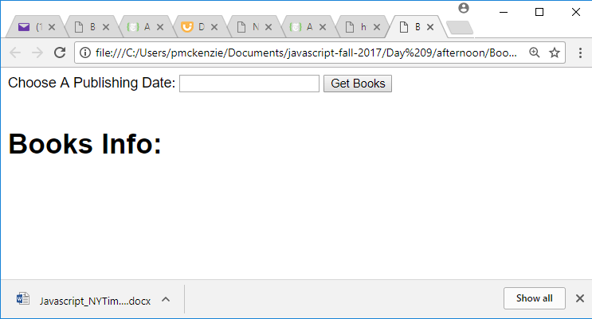
* The ‘event’ that runs the application is the click of the ‘Get Books’ button. If a user leaves the publishing date empty, the application will get the top 5 books for the current date. If the user chooses a date from the date picker, the application will get the top 5 books for that publishing date from the NY Times API.
* Once the ‘Get Books’ button has been clicked, the application should:
  + Obtain the selected values from the date picker if a date has been selected
  + Insert the selected values into the url that is used to call the NY Times API (a blank value is valid)
  + Execute an AJAX call with that url to get the response data
  + Parse that response data and output it so it looks similar to the following :  
    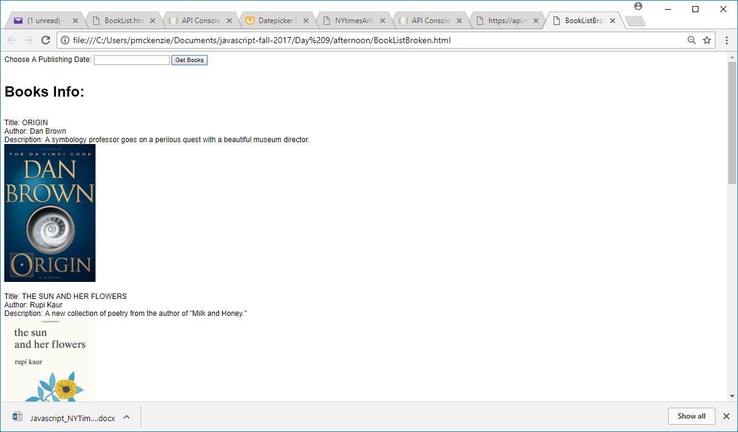
  + Changing values in the date picker should result in different data displayed:  
    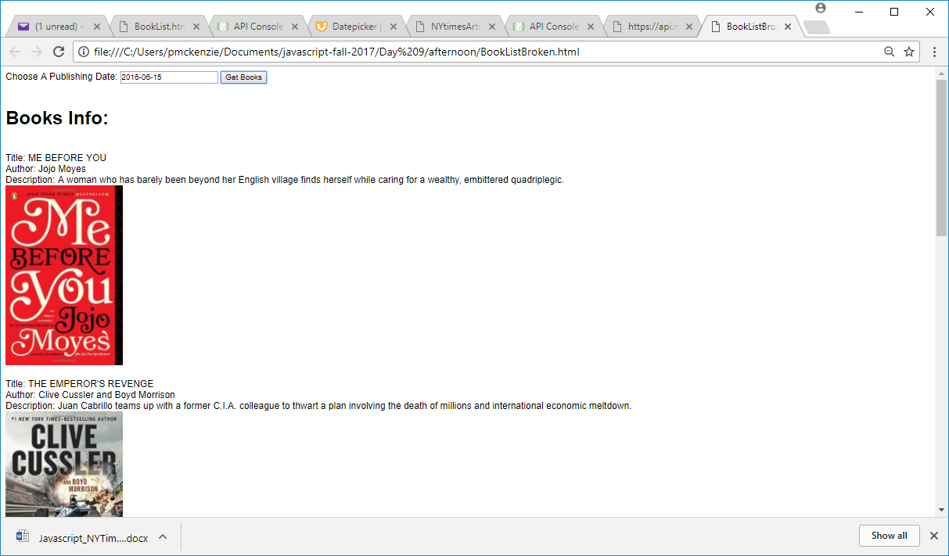

If you have any questions or wish to get some feedback on your work before the hand-in date, ask your instructor to review it with you after class.